

INSTITUTO POLITECNICO NACIONAL
CENTRO DE ESTUDIOS CIENTÍFICOS Y
TECNOLOGICOS No19
“LEONA VICARIO”

GUIA DE ESTUDIO ETS INGLÉS IV

ACADEMIA DE INGLÉS

Simple present tense
The simple present tense is one of several forms of present tense in English. It is used to describe habits, unchanging situations, general truths, and fixed arrangements. The simple present tense is simple to form. Just use the base form of the verb: (I take, you take, we take, they take) The 3rd person singular takes an -s at the end. (he takes, she takes)
Affirmative | Interrogative | Negative
I think | Do I think? | I do not think
You think | Do you think? | You do not think
He thinks | Does he think? | He does not think
She thinks | Does she think? | She does not think
It thinks | Does it think? | It does not think
We think | Do we think? | We do not think.
They think | Do they think? | They do not think.

A. Write the third person singular of the following verbs.
play ____________ go ____________
wash ____________ teach ____________
drive ____________ carry ____________
fly ____________ start ____________
help ____________ kiss ____________
watch ____________ tidy ____________
like ____________ enjoy ____________
Complete the sentences with the Present Simple of the verbs in brackets.
1. Peter and his friends __________ to school by bus. (go)
2. Elephants __________ leaves and grass. (eat)
3. David's father __________ in a hospital. (work)
4. The bank opens at 9.30 and __________ at 4.30. (close)
5. Tom and Jim __________ football every day after school. (play)
6. Mr Jones is a teacher. He __________ History. (teach)
7. Our lessons __________ at 9.00 and __________ at 3.30. (start / finish)
8. My pen friend __________ in Japan. (live)
9. Mary and her brother __________ cartoons every Sunday morning. (watch)
10. John __________ his room every day. (tidy)
Expressions used with the Present Simple
and they __________ in the woods every weekend.
Complete the blanks with the negative or the interrogative form of the
Present Simple of the verbs in brackets.
Mark: Hi, Tess! What are you doing?
Tess: I'm watching the football team.
Mark: Do you watch (watch) them every day?
Tess: No, I don't. They __________ (not play)
every day. They play four times a week.
Mark: __________ you __________ (have)
a favourite player?
Tess: No, I __________ (not have) a favourite player. Everyone on the team is
good.
Mark: __________ the attacker __________ (move) fast?
Tess: No, he __________ (not move) fast, but he's very clever. __________
you __________ (like) football, Mark?

PRESENT CONTINUOUS
1. First, we use the present continuous for things that are happening at the moment of speaking.
• I'm working at the moment.
• Please call back as we are eating dinner now.
• Julie is sleeping.
2. We can also use this tense for other kinds of temporary situations, even if the action isn't
happening at this moment.
• John's working in a bar until he finds a job in his field. (He might not be working now.)
• I'm reading a really great book.
3. We can use the present continuous for temporary or new habits (for normal habits that continue
for a long time, we use the present simple). We often use this with expressions like 'these days' or 'at
the moment'.
• He's eating a lot these days.
• She's swimming every morning (she didn't use to do this).
• You're smoking too much.
2 © www.perfect-english-grammar.com
May be freely copied for personal or classroom use.
4. Another present continuous use is for habits that are not regular, but that happen very often. In
this case we usually use an adverb like 'always', 'forever' or 'constantly'. Often, we use the present
continuous in this way to talk about an annoying habit.
• You're forever losing your keys!
• She's constantly missing the train.
STRUCTURE PRESENT CONTINUOUS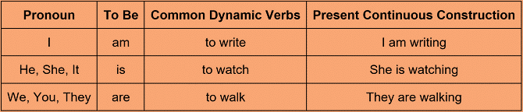
affirmative | interrogative | negative
I’m reading a book | Am I reading a book? | I ‘m not reading a book
You are going to the party | Are you going to the party? | I’m not going to the party
She is dancing salsa | Is she dancing salsa? | She isn’t dancing salsa
He is working | Is he working? | He isn’t working
My dog is barking | Is it barking? | It isn,t barking
They are eating | Are they eating? | They aren’t eeating
We are teaching | Are they teaching? | They aren’t teching

Exercises: Make the present continuous.
1. (he / walk to school now) _________________________________________________
2. (I / study at the moment) _________________________________________________
3. (I / not / sleep) _________________________________________________________
4. (you / play badminton tonight) _____________________________________________
5. (we / watch TV) ________________________________________________________
6. (she / not / work in Spain) ________________________________________________
7. (he / not / wait for the bus) _______________________________________________
8. (they / read) ________________________________________________________
9. (we / not / go to the cinema tonight) _____________________________________
10.(you / not / read the newspaper) _______________________________________
PRESENT CONTINUOUS VS PRESENT SIMPLE
What's the difference between the Present Simple / Present Continuous and how to use them.
We use the present simple tense when we want to talk about fixed habits or routines – things that don’t change.
We use the present continuous to talk about actions which are happening at the present moment but will soon finish. Compare these two statements:
(Present simple) I play tennis.
(Present continuous/ progressive) I am playing tennis.
TIME EXPRESSIONS
to identify these kind of sentences between them we use the time expressions.
Frequency Adverbs we use with the Present Simple the adverb comes before the main verb in the sentence. E.g I always go to work
Always | Occasionally
Often | Seldom
Frequently | Rarely
Sometimes | Hardly ever
Never | Anuanally

Time Expressions we use with the Present Continuous
At the moment | ‘I’m watching TV, at the moment.’
These days | ‘Paul’s living in Cardiff, these days.’
Now | What are you doing, now?’
Nowadays | ‘I think you are smoking too much, nowadays.’

:

Choose the present simple or the present continuous. Watch out for stative verbs.
1. Julie ____________ (read) in the garden.
2. What ____________ (we / have) for dinner tonight?
3. She ____________ (have) two daughters.
4. I ____________ (stay) in Spain for two weeks this summer.
5. He often ____________ (come) over for dinner.

A. Fill in the blanks with the correct form of the Present Simple or Progressive as appropiate
appropriate. Dear Sara: I ________(write) to you from our hotel. I am on vacation with my family and we_________(have) a great time. The weather is great and the sun __________(shine). I___________(look) outside my window and people _________(go) towards the beach. There are some people who ___________(swim) and others _______(sail). I________ (look) at some children. They________(play) near the edge of the beach and others ________________(build) sandcastles. Just to left of our hotel ________(be) a big restaurant. There, some people _____________(sit) and _________(drink) some kind of drink that looks delicious. The waiter_________(go) towards them and I am sure that they _________(be) ready to order. They look very hungry. At the moment my brother__________ (watch) television and my mother _____________(tell) him to get ready because we__________(go) to do some sightseeing. My
father___________(wait) for us downstairs, so I will write to you again later in the week. Have to go now. Love Paula.

SIMPLE PAST OR PAST CONTINUOUS
The past continuous and the past simple help us to show how two past actions or situations are connected. When we use these two tenses together, it shows us that the past simple action happened in the middle of the past continuous action, while it was in progress.
While I was studying, I suddenly felt sleepy.
We often use these tenses to show an action interrupting another action.
I broke my leg when I was skiing.
 | Past simple
I played video games | Did I play video games | I didn’t play video games
You lived in New York | Did you live in New York | You didn’t live in New York
He ran in the marathon | Did he run in the marathon? | He didn’t run in the marathon
She went shopping | Did she go shopping? | She didn’t go shopping
My dog barked all night | Did it barked all night? | It barked all night
They travelled to Acapulco | Did they travel to Acapulco? | They didn’t travel to Acapulco
We had a good time | Did we have a good time? | We didn’t have a good time

Past continuous
affirmative | interrogative | negative
I was working at home | Was I working at home? | I wasn’t working at home
You were studying math | Were you studying math? | You weren’t studying math
He was reading a book | Was he reading a book? | He wasn’t reading a book
She was watching tv | Was she watching tv? | She wasn’t watching tv
My cat was meowing | Was my cat meowing? | It wasn’t meowing
They were acting | Were they acting? | They weren’t acting
We were cooking dinner | Were we cooking dinner? | They weren’t cooking diner
Make the past simple: positive, negative or question.
1. I _________________ (not / drink) any beer last night.
2. She _________________ (get on) the bus in the center of the city.
3. What time _________________ (he / get up) yesterday?
4. Where _________________ (you / get off) the train?
5. I _________________ (not / change) trains at Victoria.
6. We _________________ (wake up) very late.
7. What _________________ (he / give) his mother for Christmas?

Complete the sentences with the past continuous form of the verbs in brackets.
1 I ____________________(make) my dinner at 8 o’clock last night.
2 Joe and Sam_________________ (use) the wrong program in IT yesterday.
3 Who was that guy you_______________ (dance) with at the party?
4 Paula_________________ (come) home from school when she saw an accident.
5 In 1999 my father___________ (live) in Dublin. That’s where he met my mother.
Circle the correct options.(past continuous versus past simple)
1 I listened / was listening to the radio when I heard / was hearing this fantastic song.
2 When the teacher said / was saying ‘Stop!’, I still tried / was still trying to finish the last question.
3 I feel really silly! While I danced / was dancing, I fell / was falling and broke / was breaking my elbow.
4 Tim played / was playing a computer game when his mum called / was calling him for lunch.
5 I looked / was looking for a file on my memory stick when I noticed / was noticing there was a virus.
6 Ron found / was finding an interesting website about dance music while he surfed / was surfing the internet.
7 My mum had / was having breakfast near the computer when she spilled / was spilling her cup of coffee on the keyboard.

PRESENT PERFECT SENTENCES
We use the present perfect:
for something that started in the past and continues in the present:
They've been married for nearly fifty years.
She has lived in Liverpool all her life.
when we are talking about our experience up to the present:
I've seen that film before.
I've played the guitar ever since I was a teenager.
We often use the adverb ever to talk about experience up to the present:
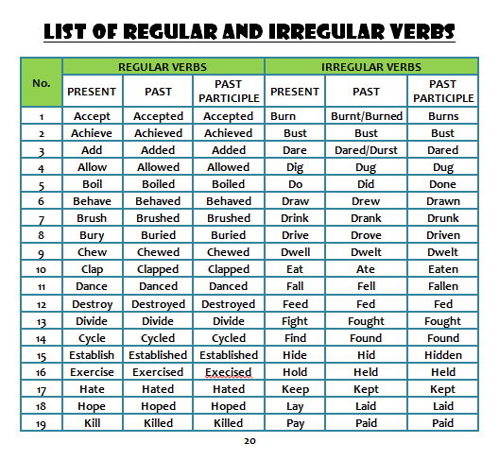
My last birthday was the worst day I have ever had.
 | Positive | Negative | Question
I / you / we / they | I have spoken. | I have not spoken. | Have I spoken?
he / she / it | He has spoken. | He has not spoken. | Has he spoken?

Make the present perfect: positive, negative or question.
1. (you / keep a pet for three years)________________________________
2. (you / come here before?)______________________________________
3. (it / rain all day?)______________________________________________
4. (who / we / forget to invite?)____________________________________
5. (we / not / hear that song________________________________________
ALREADY AND YET
We use already to say that something happened sooner than expected.
Already usually comes before the main verb or between an auxiliary or modal verb and the main verb. I am sorry, she has already gone home.
The film has already started.
She's only four years old and she can already read.
We use yet in questions or negative statements to talk about things that we expected to happen before now. Have you finished work yet?
I haven't seen the new James Bond film yet.
Have you met our new colleague? ~ Not yet.
EXECISES WRITE ALREADY OR YET IN EACH SENTENCE
1. She has not ………………… started working on the project. already yet
2. I have ………………….. sent the payment. already yet
3. As …………………, I haven’t had time to talk to her. already yet
4. I have …………………. finished. already yet
5. He was tired, ………………….. he didn’t give up. already yet.

SINCE AND FOR IN PRESENT PERFECT
We often use for and since when talking about time.
for + period: a "period" is a duration of time - five minutes, two weeks, six years. For means "from the beginning of the period to the end of the period".
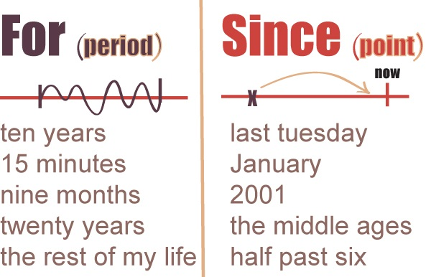
since + point: a "point" is a precise moment in time - 9 o'clock, 1st January, Monday. Since means "from a point in the past until now".

Complete these sentences with either for or since:
1. I haven’t seen her .......... five days.
2. Alice has changed a lot .......... she got promoted.
3. We haven’t had severe rain .......... 2005.
4. I have been waiting for this theatre .......... a month.
5. The child has been sleeping .......... 10 o’clock.
6. My wife and I have been married .......... 2011.
7. It’s been snowing .......... 30 minutes.
8. I have been working .......... the same municipality since I graduated from the university.
9. Berta has been walking .......... 4 hours.
10. They have fixed many broken cars .......... this morning.

ZERO, FIRST, AND SECODN CONDITINAL SENTENCES
Zero conditional
This conditional is used when the result will always happen.
if water reaches 100 degrees, it always boils.
Simple present/simple present
It's a fact. I'm talking in general, not about one particular situation. The result of the 'if clause' is always the main clause.
First conditional
The first conditional is used to express the future consequence of a realistic possibility now or in the future. For example,
If I miss the train, I’ll take the next one.
Simple present/future will
There is a 50% chance that the first part of this sentence (the action following ‘if’) will happen.
Second conditional.
The second conditional is used to express the consequence of an unrealistic action or situation in the present or future. The situation can be:
- Very improbable (1-5% probability)
- Completely unrealistic (with a 0% probability) example
If I won the lottery, I would travel around the world.
Simple past/auxiliary would
Make sentences with the zero conditional.
For example:
(not / rain / the flowers / die)
If it doesn't rain, the flowers die.
1. (I / wake up late / I / be late for work)
_______________________________________________________________
2. (my husband / cook / he / burn the food)
_______________________________________________________________
3. (Julie / not wear a hat / she / get sunstroke)
_______________________________________________________________
4. (children / not eat well / they / not be healthy)
_______________________________________________________________
5. (you / mix water and electricity / you / get a shock)
_______________________________________________________________

Fill in the gaps in the following sentences using the First Conditional.
1 If you ________ (not/exercise) and eat healthily, you ________
(put) on weight.
2 If we ________ (go) to the cinema, we ________ (buy) some
popcorn.
3 If he ________ (go) to the gym, he ________ (get) quite muscular.
4 If you ________ (not/dress) warmly, you ________ (catch) a cold.
5 She ________ (feel) sick if she ________ (eat) too much chocolate.
Put the verb into the correct tense to make the second conditional.
1. If I _________________ (be) you, I _________________ (get) a new job.
2. If he _________________ (be) younger, he _________________ (travel) more.
3. If we _________________ (not / be) friends, I _________________ (be) angry with
you.
4. If I _________________ (have) enough money, I _________________ (buy) a big
house.
5. If she _________________ (not / be) always so late, she _________________ (be)
promoted.

PARTICIPIAL ADJECTIVES ENDING IN-ED /-ING
Adjectives ending in -ed show what has happened to a person or thing.
He was surprised by the result of his test.
Adjectives ending in -ing show the effect which something has on a person or thing.
The test results were surprising to him.
Choose the correct adjective.
1. My nephew was (amusing / amused) by the clown.
2. It's so (frustrating / frustrated)! No matter how much I study I can't seem to remember this
vocabulary.
3. This lesson is so (boring / bored)!
4. I'm feeling (depressing / depressed), so I'm going to go home, eat some chocolate, and go
to bed early with a good book.
5. I thought her new idea was absolutely (fascinating / fascinated).
6. This maths problem is so (confusing / confused). Can you help me?
7. The teacher was really (amusing / amused) so the lesson passed quickly.
8. The journey was (exhausting / exhausted) – twelve hours by bus!
9. The plane began to move in a rather (alarming / alarmed) way.
10. He was (frightening / frightened) when he saw the spider.

PASSIVE VOICE SENTENCES
The passive voice is used when:
We do not know who did the action
Example: The documents were stolen.
(We don’t know who stole the documents)
The receiver of the action is more important
Example: The pyramids were built nearly 5,000 years ago by the ancient Egyptians.
(We want to emphasize “pyramids” more than “ancient Egyptians”)
Note: we focus in the action not in the subject
PASSIVE VOICE GRAMMAR

Present Simple
Type of sentence | Subject | Verb | Object
Active sentence: | Paul | builds | a house.
Passive sentence: | A house | is built | by Paul.
Past Simple
Type of sentence | Subject | Verb | Object
Active sentence: | James | made | a film.
Passive sentence: | A film | was made | by James.
Present Perfect
Type of sentence | Subject | Verb | Object
Active sentence: | Peter | has written | a book.
Passive sentence: | A book | has been written | by Peter.

Passive voice - Test 1
A - Are the sentences written in Active or Passive?
Steven likes to play baseball.
Active Passive
Bingo is played in Britain.
Active Passive
He lost his keys yesterday.
Active Passive
A letter was written.
Active Passive
They are listening to their music.
Active Passive
They often read e-mails.
Active Passive
These cars are produced in Italy.
Active Passive
French is spoken in Niger.
Active Passive
Lots of houses were destroyed.
Active Passive
The bus driver was hurt.
Active Passive

